SIMATS ENGINEERING (SAVEETHA SCHOOL OF ENGINEERING)
Department of Computer Science and Engineering
CO3 ASSESSMENT TOOL 1 – Git & Docker Technical Assignment

Course Code: | CSA10 / CSA1063 | Course Title: | Software Engineering
CO Assessed: | CO3 | Assessment: | Assessment Tool 1 – Git & Docker Technical Assignment
Weightage: | 20% | Total Marks: | 25
CO3 Statement: | Build full-stack applications with an emphasis on containerization, version control, and collaborative development
Student Name: |  | Reg. No.:
Date: |  | Duration: | 60 minutes

Code of Conduct
I __________________________ (Name / Reg No) certify that this submission is my original work and that I have adhered to the guidelines specified for this assessment. I understand that any violation of academic integrity rules will result in disciplinary action.
Signature of the Student: _________________________
Annexure A – Git & Docker Technical Assignment
Instructions to Students:
Each student has been assigned an individual problem statement. Based on the assigned problem statement, prepare a Git & Docker Technical Assignment by applying version control and containerization concepts. Your report should include appropriate diagrams, screenshots, commands, and explanations wherever applicable.

Assignment Questions
- Problem Analysis
  - Explain the assigned problem statement and identify the project objectives, functional requirements, and expected outcomes.
- Project Structure Design
  - Design and explain the folder structure of your project repository.
  - Justify the purpose of each major folder and file included in the repository.
- Git Repository Initialization
  - Create a Git repository for the project.
  - Explain the steps involved in repository initialization and describe the purpose of the essential Git files.
- Git Branching Strategy
  - Design a suitable branching strategy (e.g., Main, Development, Feature, Release, Hotfix).
  - Justify why the selected branching model is appropriate for the assigned project.
- Version Control Workflow
  - Demonstrate the Git workflow by performing meaningful commits, branch creation, merging, conflict resolution (if applicable), and repository synchronization.
  - Explain the purpose of each Git operation performed.
- Commit History Analysis
  - Present the commit history of the project.
  - Explain how commit messages follow good version control practices and contribute to project maintenance.
- Docker Environment Design
  - Explain why Docker is suitable for the assigned project.
  - Identify the application components that require containerization.
- Dockerfile Development
  - Design and explain the Dockerfile required to containerize the application.
  - Describe the purpose of each instruction used in the Dockerfile.
- Docker Compose Design
  - Develop a Docker Compose configuration for the project.
  - Explain the services, networking, volumes, environment variables, and dependencies used.
- Container Deployment and Testing
  - Demonstrate the execution of the application using Docker containers.
  - Explain the testing procedure and provide evidence that the application runs successfully.
- Benefits of Git and Docker
  - Discuss how Git and Docker improve collaboration, version management, portability, deployment, scalability, and maintainability for your assigned project.
- Challenges and Improvements
  - Identify the challenges encountered during implementation.
  - Suggest possible improvements and future enhancements for the Git workflow and Docker deployment.

Expected Deliverables
- Technical report (10 pages)
- Git repository with complete commit history
- Source code of the assigned project
- Dockerfile
- Docker Compose file (docker-compose.yml)
- Screenshots of Git operations and Docker execution
- Architecture and workflow diagrams

Rubrics for Calculation
Evaluation Criteria | Excellent (4 Marks) | Good (3 Marks) | Satisfactory (2 Marks) | Needs Improvement (1 Mark)
Problem Analysis & Project Design(20%) | Clearly explains the problem statement, objectives, requirements, expected outcomes, and well-organized project structure with proper justification. | Good analysis and project structure with minor omissions. | Basic analysis and repository structure with limited justification. | Incomplete or unclear analysis and project organization.
Git Repository & Branching Strategy(20%) | Repository initialized correctly with appropriate branching strategy, clear workflow, and proper repository organization. | Repository and branching strategy are mostly correct. | Basic Git setup with limited branching implementation. | Incorrect or incomplete Git repository and branching strategy.
Version Control Workflow & Commit History(10%) | Demonstrates meaningful commits, branching, merging, synchronization, conflict resolution, and professional commit messages with clear history. | Most Git operations demonstrated correctly with good commit history. | Limited Git workflow and commit practices. | Poor workflow and inadequate commit history.
Docker Implementation(20%) | Well-designed Docker environment, Dockerfile, and Docker Compose configuration with clear explanation of services, networking, volumes, and dependencies. | Functional Docker implementation with minor issues. | Basic Docker implementation with limited explanation. | Incomplete or incorrect Docker implementation.
Deployment, Testing & Results(15%) | Application successfully deployed and tested with appropriate screenshots and evidence of successful execution. | Deployment completed with minor issues. | Partial deployment and testing demonstrated. | Deployment unsuccessful or insufficient evidence.
Documentation, Challenges & Future Enhancements(15%) | Professional report (10–15 pages) with diagrams, screenshots, references, discussion of benefits, challenges, and future improvements. | Good documentation with minor omissions. | Basic documentation with limited discussion. | Poor documentation and insufficient analysis.

Criteria | Mark
System Requirement Analysis (30%) | /5
Selection of Software Architecture (25%) | /5
Architecture Diagram and Component Design (20%) | /5
Component Interaction and Quality Attribute Analysis (15%) | /5
Architectural Justification and Technical Presentation (10%) | /5
TOTAL | /25

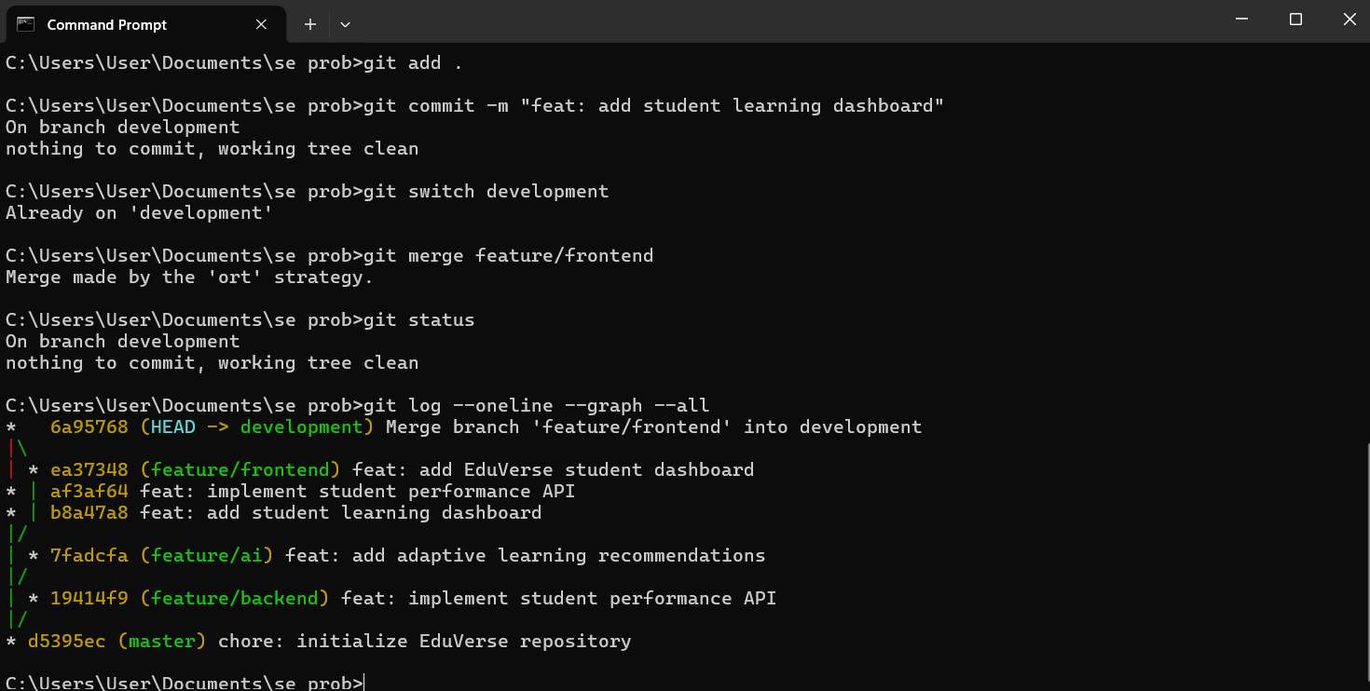

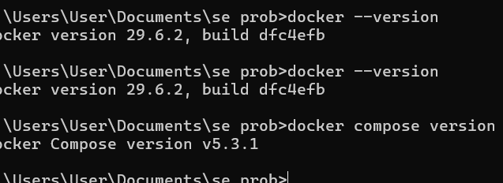

1. Problem Analysis

1.1 Problem Statement
EduVerse is an AI-powered adaptive learning and student success analytics platform designed to overcome the limitations of traditional one-size-fits-all education systems.
Traditional Learning Management Systems mainly provide students with the same learning materials and assessments without sufficiently considering differences in their academic performance, learning progress, engagement, and individual learning needs. As a result, students who are struggling may not be identified until their academic performance has already declined.
EduVerse addresses this problem by continuously analyzing student learning behavior, assessment results, engagement patterns, and academic progress. The platform uses these insights to identify learning gaps, recommend suitable learning resources, provide personalized study plans, and identify students who may be academically at risk.
The platform also provides educators and academic administrators with analytics dashboards that support data-driven instructional decisions and timely academic interventions.

1.2 Project Objectives
The main objectives of EduVerse are:
- To develop an AI-powered adaptive learning platform for personalized education.
- To analyze student learning behavior, assessment results, and engagement data.
- To identify individual learning gaps.
- To recommend customized learning resources based on student progress.
- To predict student academic performance using machine learning algorithms.
- To generate personalized study plans.
- To provide analytics dashboards for educators and administrators.
- To identify academically at-risk students at an early stage.
- To improve student engagement and learning outcomes through intelligent recommendations.

1.3 Functional Requirements

Student Module
The student module should allow students to:
- Register and securely log in.
- Access available learning content.
- View personalized learning resources.
- Complete assessments and quizzes.
- View assessment results.
- Track learning progress.
- Receive personalized recommendations.
- Follow an individualized study plan.
- View their performance and learning analytics.

Educator Module
The educator module should allow educators to:
- Monitor student performance.
- View student progress.
- Analyze assessment results.
- Monitor engagement levels.
- Identify students with learning difficulties.
- View students who are academically at risk.
- Review AI-generated recommendations.
- Make appropriate academic interventions.

Adaptive Learning Module
The adaptive learning component should:
- Analyze student learning behavior.
- Identify knowledge gaps.
- Analyze assessment performance.
- Recommend appropriate learning resources.
- Adapt learning pathways according to student progress.
- Generate personalized study recommendations.

Analytics and Prediction Module
The analytics module should:
- Collect student performance information.
- Analyze learning and engagement patterns.
- Generate performance analytics.
- Predict potential academic outcomes.
- Identify at-risk students.
- Provide actionable insights to educators.

Administration Module
The administrator should be able to:
- Manage users.
- Manage courses and learning resources.
- Monitor platform usage.
- View overall academic analytics.
- Monitor student success indicators.

1.4 Non-Functional Requirements
The system should also satisfy the following quality requirements:
Requirement | Description
Performance | The platform should provide responses and analytics within an acceptable time.
Scalability | The system should support increasing numbers of students, courses, and assessments.
Security | Student and academic information must be protected from unauthorized access.
Availability | The platform should remain accessible to students and educators.
Maintainability | The codebase should be modular and easy to update.
Portability | The application should be deployable across different environments using Docker.
Usability | Students and educators should be able to use the platform easily.
Reliability | Analytics, recommendations, and academic information should be generated consistently.

1.5 Expected Outcomes
The expected outcomes of EduVerse are:
- Personalized learning experiences for individual students.
- Improved academic performance and learning achievement.
- Early identification of students requiring academic support.
- Increased student engagement through adaptive content.
- Better instructional decisions using predictive analytics.
- Improved student retention and course completion.
- Continuous monitoring of academic performance.
- Data-driven academic planning.
- A scalable AI-enabled digital learning environment.
These outcomes correspond to the expected outcomes specified in the assigned problem statement.

2. Project Structure Design
The EduVerse repository can be organized into separate components so that application development, deployment, documentation, and configuration are clearly separated.

2.1 Proposed Repository Structure
EduVerse/
│
├── frontend/
│ ├── src/
│ │ ├── components/
│ │ ├── pages/
│ │ ├── layouts/
│ │ ├── contexts/
│ │ ├── utils/
│ │ └── services/
│ │
│ ├── public/
│ ├── package.json
│ ├── package-lock.json
│ ├── vite.config.ts
│ ├── tsconfig.json
│ ├── Dockerfile
│ └── .dockerignore
│
├── backend/
│ ├── app/
│ │ ├── routes/
│ │ ├── models/
│ │ ├── services/
│ │ └── utils/
│ │
│ ├── requirements.txt
│ ├── Dockerfile
│ └── .dockerignore
│
├── ai-service/
│ ├── models/
│ ├── services/
│ ├── requirements.txt
│ └── Dockerfile
│
├── database/
│ └── init.sql
│
├── docs/
│ ├── architecture/
│ ├── diagrams/
│ └── screenshots/
│
├── docker-compose.yml
├── .gitignore
├── .env.example
└── README.md

Note: This is the proposed repository organization for the technical design. If the existing EduVerse application uses a different folder structure, the actual repository should retain its existing application structure rather than unnecessarily moving files.

2.2 Purpose of Major Folders

frontend/
Contains the user interface of EduVerse.
It provides interfaces for:
- Students
- Educators
- Administrators
- Dashboards
- Learning content
- Assessments
- Progress tracking

backend/
Contains the server-side application logic and APIs.
It handles:
- Authentication
- User management
- Course data
- Student records
- Assessment information
- Progress information
- Communication with the database
- Communication with AI services

ai-service/
Contains the AI-related functionality of the platform.
It can handle:
- Learning-gap identification
- Personalized recommendations
- Student performance prediction
- At-risk student identification
- Adaptive learning decisions

database/
Contains database initialization and related database scripts.
The database stores information such as:
- Student profiles
- Courses
- Assessments
- Results
- Learning progress
- Engagement information
- Recommendations

docs/
Contains project documentation, architecture diagrams, workflow diagrams, and implementation screenshots.
This makes technical documentation easier to maintain alongside the source code.

docker-compose.yml
Defines the application's containerized services and their relationships.
It can coordinate:
Frontend
Backend
AI Service
Database

and define their networking, environment variables, dependencies, and persistent storage.

.gitignore
Specifies files that should not be tracked by Git.
Typical examples include:
node_modules/
.env
dist/
__pycache__/

This prevents unnecessary files and sensitive configuration from being committed.

.env.example
Provides an example of the environment variables required by the application without storing actual passwords, API keys, or other secrets.

README.md
Contains:
- Project description
- Features
- Technologies used
- Installation instructions
- Git workflow
- Docker instructions
- Application usage information

Dockerfile
Defines how an individual application component is packaged into a Docker image.
Separate Dockerfiles can be used for the frontend, backend, and AI service when required.

3. Benefits of Git and Docker

3.1 Benefits of Git

Collaboration
Git allows multiple developers to work on different EduVerse features using separate branches.
For example:
development
│
├── feature/frontend
├── feature/backend
└── feature/ai

Developers can independently work on features and merge completed changes into the development branch.

Version Management
Git maintains the complete history of the project.
For example:
chore: initialize EduVerse repository
feat: add student dashboard
feat: implement performance analytics
feat: add adaptive recommendations
build: add Docker configuration
fix: resolve authentication issue

This makes it possible to identify when and why a change was introduced.

Branch-Based Development
Feature branches prevent incomplete functionality from directly affecting the stable version of EduVerse.
The main branch can contain stable code while development takes place through feature and development branches.

Backup and Repository Synchronization
GitHub provides a remote copy of the repository.
Developers can synchronize their local work using:
git pull
git push

This improves collaboration and provides a centralized project repository.

3.2 Benefits of Docker

Portability
Docker packages the application and its dependencies into containers.
Therefore, EduVerse can be executed consistently across:
- Developer machines
- Testing environments
- Servers
- Cloud environments

Consistent Environment
Without Docker, differences between developer environments can cause problems such as:
"It works on my computer."

Docker reduces these differences by using the same container configuration.

Deployment
Docker makes deployment easier because the application can be packaged as images and deployed to another environment without manually installing every dependency.

Scalability
Individual services can be scaled independently.
For example:
EduVerse
│
┌───────┼────────┐
▼ ▼ ▼
Frontend Backend AI Service
│
▼
Database

If backend demand increases, additional backend containers can be deployed without necessarily duplicating unrelated services.

Maintainability
Each major component can be isolated into its own container.
For example:
Frontend Container
Backend Container
AI Service Container
Database Container

This makes troubleshooting and maintenance easier.

Dependency Isolation
Different services can have their own dependencies and runtime environments without interfering with one another.

Reproducible Deployment
The Dockerfile and Docker Compose configuration provide a repeatable method for building and running EduVerse.
This is particularly useful for testing and deployment.

4. Challenges and Improvements

4.1 Challenges Encountered During Implementation

Challenge 1: Git Merge Conflicts
While working with multiple branches, changes to the same files can result in merge conflicts.
For example:
CONFLICT (content): Merge conflict in README.md

The conflict must be manually resolved before the merge can be completed.
Solution: Review the conflicting changes, retain the correct content, stage the resolved file, and complete the merge commit.

Challenge 2: Git Commit Organization
Creating too many small or unclear commits can make the repository difficult to understand.
Solution: Use meaningful commit messages such as:
feat: add student dashboard
fix: resolve authentication issue
build: add Docker configuration
docs: update deployment instructions

Challenge 3: Docker Environment Configuration
Docker requires the correct configuration of:
- Ports
- Environment variables
- Service dependencies
- Network configuration
- Volumes
Incorrect configuration can prevent containers from communicating correctly.
Solution: Define these settings systematically in docker-compose.yml and use .env.example for configuration documentation.

Challenge 4: Docker Build Errors
During containerization, the EduVerse frontend may fail during:
npm run build

because of application-level TypeScript errors, missing files, incorrect import paths, or differences between Windows and Linux environments.
For example, Linux-based Docker containers are case-sensitive with file paths, so inconsistencies such as:
AuthContext.tsx

versus:
authContext.tsx

can cause build failures.
Solution: Ensure that imported files exist, import paths use the correct capitalization, and the application successfully builds before creating the Docker image.

Challenge 5: Missing Dependencies
A Docker container starts with a clean environment. Dependencies available on the developer's computer may not automatically be available inside the container.
Solution: Explicitly define dependencies in files such as:
package.json
requirements.txt

and install them during the Docker image build.

Challenge 6: Persistent Database Data
Containers are designed to be replaceable. If database data is stored only inside a container, it can be lost when the container is removed.
Solution: Use Docker volumes for persistent database storage.

4.2 Future Improvements

Improved Git Workflow
The Git workflow can be improved by using:
- Pull requests for feature integration.
- Mandatory code reviews.
- Protected main branch.
- Automated testing before merging.
- Clear branch naming conventions.
- Standardized commit messages.

Continuous Integration and Deployment
A CI/CD pipeline can automatically:
Git Push
↓
Build
↓
Run Tests
↓
Build Docker Image
↓
Security Checks
↓
Deploy

This would reduce manual deployment effort.

Container Security
Future versions can improve Docker security by:
- Using minimal base images.
- Running containers as non-root users.
- Avoiding hard-coded credentials.
- Scanning images for vulnerabilities.
- Managing secrets securely.

Improved Scalability
The application can eventually be deployed using container orchestration platforms such as Kubernetes to manage:
- Multiple containers
- Automatic scaling
- Service discovery
- Load balancing
- Fault recovery

Enhanced AI Capabilities
Future versions of EduVerse can improve:
- Student performance prediction.
- Learning-gap detection.
- Personalized recommendations.
- At-risk student prediction.
- Adaptive learning pathways.

Advanced Analytics
Future versions can provide educators with:
- Real-time student engagement analytics.
- Course-level performance analysis.
- Learning trend analysis.
- Cohort comparisons.
- Early-warning notifications.

Monitoring
Application and container monitoring can be introduced using appropriate monitoring and logging tools to track:
- Application performance.
- Container health.
- API failures.
- Resource utilization.
- Database performance.

Conclusion
EduVerse combines adaptive learning, student analytics, predictive capabilities, and personalized recommendations to address the limitations of standardized digital education. A well-organized Git repository provides version control, collaboration, and maintainability, while Docker provides portability, consistent deployment environments, service isolation, and scalability.
The combination of Git and Docker therefore provides a suitable development and deployment foundation for EduVerse. The proposed improvements, including CI/CD, stronger container security, orchestration, monitoring, and enhanced AI capabilities, can further improve the reliability and scalability of the platform.

